**Full Stack Development II – Lab 10**

* ES6 Promises & Error Exercises

**Developer Note:**

* You may use the JS playground for development  
  <https://repl.it/languages/nodejs>
* Create separate files for each exercise

**Exercise 1:**

* Write a function **appendMyArray**  that takes an array and value as parameters
* The function will have the following requirements
  + Use the array push method to append the value to the array
  + Implement a try..catch block to capture any errors and log to the error message in console
  + Implement a finally statement that will output the final value of the array

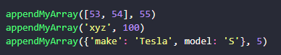

The following output is expected:  
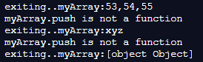

**Exercise 2:**

* Write a function **tryCatchFinally**  that takes no parameters
* The function will have the following requirements
  + Implement a try...catch block to capture any errors and log the error message in console
  + Create an error object with the message ***“throwing an error”*** and use the throw keyword to throw the message within the body of the try..catch block
  + Implement a finally statement that output the message ***“runs finally.”***

Invoke the function:



The following output is expected:  


**Exercise 3:**

* Write a function **compareNumToTen** that takes a number as an argument and returns a **Promise** that tests and rejects if the value is less than or resolves if greater than the value 10.

***Promise Reference***[**https://developer.mozilla.org/en-US/docs/Web/JavaScript/Reference/Global_Objects/Promise**](https://developer.mozilla.org/en-US/docs/Web/JavaScript/Reference/Global_Objects/Promise)

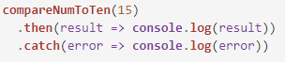

**Output**



**Exercise 4:**

* Write two functions that use Promises that you can chain! The first function, **makeUpperCase(),** will take in an array of words and capitalize them, and then the second function, **sortWords(),** will sort the words in alphabetical order. If the array contains anything but strings, it should throw an error.

***Promise Chaining Reference***

<https://developer.mozilla.org/en-US/docs/Web/JavaScript/Reference/Global_Objects/Promise>



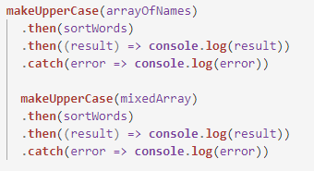

**Output** 

**Exercise 5:**

* Use the **Promise.all** syntax to resolve all three promises below and return a new promise. Call the function and use the thenable .then() keyword to output the result.

***Promise.all() Reference***[**https://developer.mozilla.org/en-US/docs/Web/JavaScript/Reference/Global_Objects/Promise/all**](https://developer.mozilla.org/en-US/docs/Web/JavaScript/Reference/Global_Objects/Promise/all)

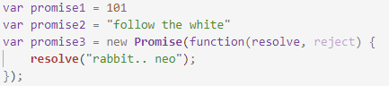

**Output**

* 